

Submitted By:
Umair Umar CE-25-107
Assignment:
CA Lab No. 4
Submitted To:
Mehmood
For the fulfillment of,
Circuit Analysis Lab
Department of Computer Engineering
University of Engineering and Technology, Lahore

Circuit Analysis – Lab 4

Objective
To make measurements in constructed parallel circuits using a Digital Multimeter (DMM).

Equipment Required
Power Supply, Breadboard, Connecting wires, Resistances, DC Ammeter, DC Voltmeter.

Task 1:

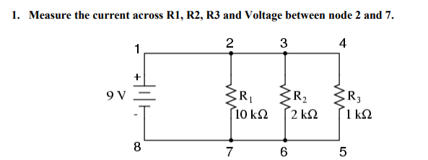

Theoretical Values – Task 1
Since all resistors are in parallel, the voltage across each is equal to the source voltage (9V).
I1 = V/R1 = 9V / 10,000Ω = 0.9 mA
I2 = V/R2 = 9V / 2,000Ω = 4.5 mA
I3 = V/R3 = 9V / 1,000Ω = 9.0 mA
Voltage between node 2 and 7 = 9V

R1 Current | R2 Current | R3 Current | Voltage (Node 2–7)
0.9 mA | 4.5 mA | 9.0 mA | 9 V

Practical Values – Task 1
Values obtained from simulation in Proteus:

R1 Current | R2 Current | R3 Current | Voltage (Node 2–7)
0.9 mA | 4.5 mA | 9.0 mA | 9 V

Task 2:

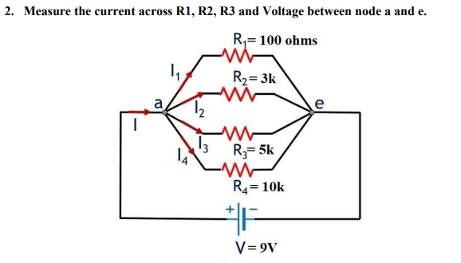

Theoretical Values – Task 2
Voltage across each resistor = 9V (parallel circuit).
I1 = 9V / 100Ω = 90.0 mA
I2 = 9V / 3,000Ω = 3.0 mA
I3 = 9V / 5,000Ω = 1.8 mA
I4 = 9V / 10,000Ω = 0.9 mA
Voltage between node a and e = 9V

R1 Current | R2 Current | R3 Current | R4 Current | Voltage (a–e)
90.0 mA | 3.0 mA | 1.8 mA | 0.9 mA | 9 V

Practical Values – Task 2
Values obtained from simulation in Proteus:

R1 Current | R2 Current | R3 Current | R4 Current | Voltage (a–e)
89.9 mA | 3.0 mA | 1.8 mA | 0.9 mA | 8.99 V

Note: Minor differences (e.g., 89.9 mA vs 90 mA, 8.99V vs 9V) are due to simulator rounding and are negligible.

Post Lab Questions

Q1. Why is the value of voltage across each resistor in a parallel circuit the same?
In a parallel circuit, all resistors share the same two nodes (connection points). Since voltage is defined as the potential difference between two points, and all resistors are connected between the same two points, the voltage across each resistor must be identical and equal to the source voltage. This is a fundamental property of parallel circuits: same voltage, different currents.

Q2. When parallel resistors are of three different values, which has the greatest power loss?
The resistor with the smallest resistance has the greatest power loss. Power is given by P = V²/R. Since voltage is the same across all parallel resistors, a smaller resistance results in higher current and therefore higher power dissipation.

Q3. How does the current across any branch of a parallel circuit vary?
The current through each branch of a parallel circuit varies inversely with the resistance of that branch, as given by Ohm's Law: I = V/R. Since the voltage is the same across all branches, a branch with lower resistance carries more current and a branch with higher resistance carries less current. The total current supplied by the source equals the sum of all individual branch currents (Kirchhoff's Current Law).

Q4. What happens to total resistance in a circuit with parallel resistors if one of them opens (is removed)?
If one parallel resistor is removed (opened), the total resistance of the circuit increases. This is because there are now fewer parallel paths for current to flow through. The formula for total parallel resistance is 1/RT = 1/R1 + 1/R2 + ... + 1/Rn. Removing one term reduces the sum, which means RT increases. As a result, the total current drawn from the source also decreases, while the voltage remains the same.

